

**The Superior University Lahore**

**Faculty of Computer Science & Information**

**Technology**

**Name: Alishba Haroon**

**Roll No: BSAI-116-4C**

**Date: 21 Mar 2025**

**Subject: PAI LAB**

**Object Detection and Alert System**

This utilizes OpenCV and YOLOv3 for real-time object detection in video streams. It is designed to detect objects, particularly people, and sends email alerts when a person is detected.

1. **Importing Required Libraries**

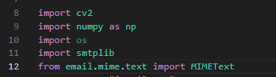

* cv2: OpenCV for image processing and video capture.
* numpy: For numerical computations, such as color assignments.
* os: For handling file paths.
* smtplib: For sending email alerts.
* MIMEText: To format email messages.

1. **Email Alert Function**

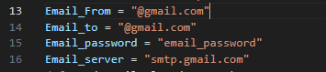

* These variables store the sender and receiver email addresses and the email server details.
* Replace them with actual credentials to make email alerts functional.

**Function to Send Email Alerts**

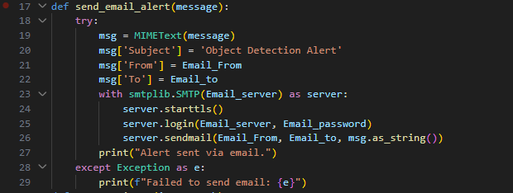

* Formats and sends an email notification when a person is detected in the video feed.

1. **Processing an Image for Object Detection**

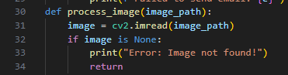

* Reads an image file using OpenCV.
* If the image is not found, it prints an error and exits.

**Loading YOLO Model**

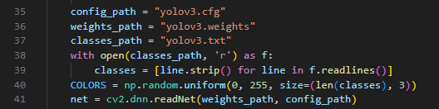

* Loads YOLO configuration, weights, and class names.
* Assigns random colors for different object classes.
* Loads the YOLO model using cv2.dnn.readNet().

**Preprocessing the Image**

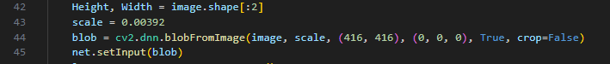

* Resizes the image to 416x416 pixels to match YOLO’s input size.
* Converts it into a blob for YOLO processing.
* Sets the input to the YOLO network.

**Running YOLO Model**



* Extracts the output layers where YOLO makes predictions.
* Runs forward propagation through the YOLO network.

**Processing Detections**

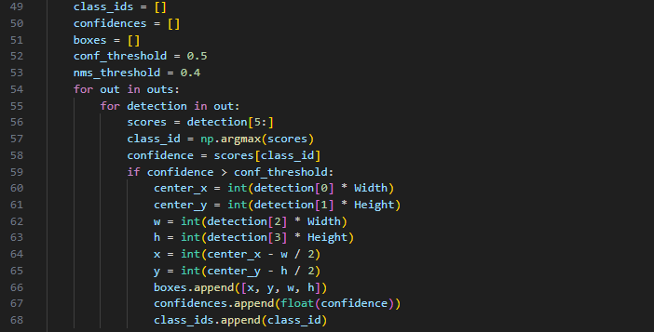

* Loops through YOLO’s detections and filters objects with confidence > 50%.
* Computes bounding box coordinates.

**Applying Non-Maximum Suppression (NMS)**

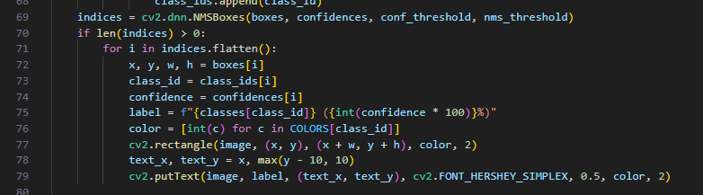

* NMS removes duplicate bounding boxes.
* Draws labeled bounding boxes around detected objects.

**Saving and Displaying the Processed Image**

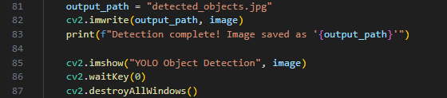

* Saves the annotated image with detected objects.
* Displays it in a window.

**Real-Time Object Detection (Webcam)**

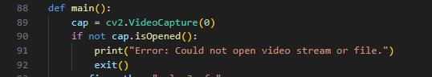

* Captures live video from the webcam.

**Processing Each Frame**

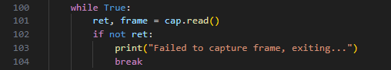

* Reads frames from the video feed.

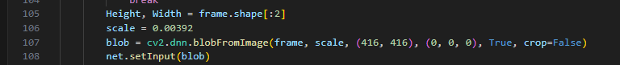

* Prepares each frame for YOLO processing.

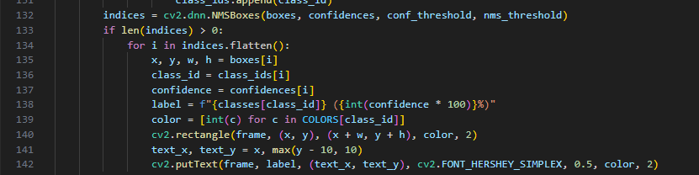

* Draws bounding boxes and labels for detected objects.

**Sending Email Alerts**

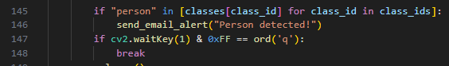

* Sends an email alert if a person is detected.

**Displaying Video and Exiting**

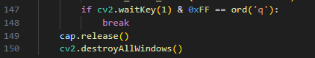

* Press 'q' to exit the real-time detection.